**Week 3 Lab Assembler**

**Group 65**

**Integrants: 110504517 李睿穎 (Leader)，110504518 鍾秉均 (Member)**

**Full Code**

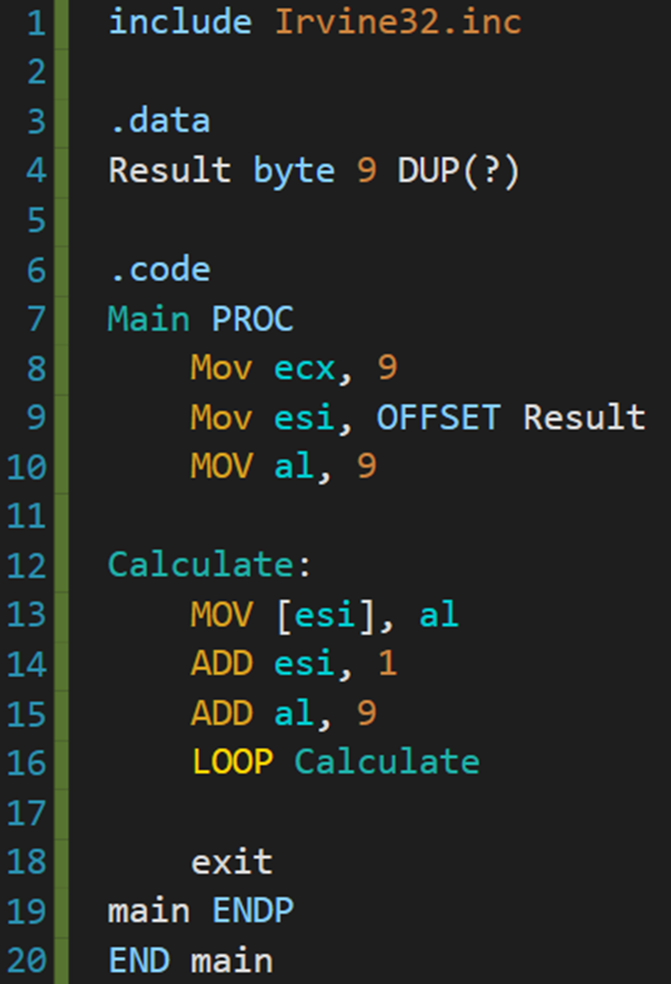

**Execution flow**

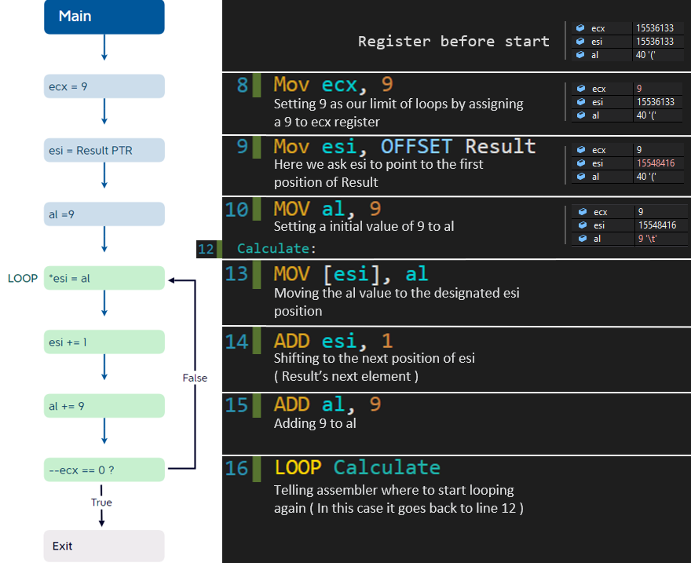

(Register status when looping at next page)

Basically what we did was simplifying the multiplication as a continuous sum of 9 to al register, and everytime we finished adding 9 to it, we saved the result to the designated position of "esi" (Result current element), then shifted to our next position. Then it just repeats this process 9 times.

**Register status when looping**

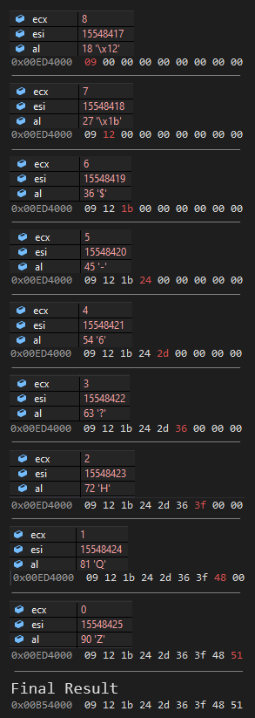

**Review for the class**

For this week’s class we learned how to do loops in assember, for us it was a completely new experience because doing loops in assembler is much different than doing it in the languages that we learned on our freshman year. We also learned about the uses of “esi” and “ecx” registers in looping, which both of them function as our index, one being as the “limit” and the other being our pointer.